Oldfield Primary School

It’s fun to learn

Starting School

Introduction

The purpose of this booklet is to help ensure that your child gets the best possible start in the Early Years Foundation Stage at Oldfield.

In it we will outline our induction arrangements, provide some important information about our school day and inform you how you can support your child at school.

You will also receive a Parent’s Admission Pack which we issue to all new pupils at the first meeting. This contains more general information about the school plus a number of additional documents you will need to complete and return to us.

We aim to make your child’s transition to school, run as smoothly and happily as possible. If you would like any further information please ask – we will be happy to help in any way we can.

Richard Jarrett
Headteacher

Induction

Induction starts during the Summer Term when the Early Years class teachers visit most children in their nursery or at home. It continues with a visit to their new class, so they can meet and play with their future classmates, and join in some typical classroom activities. The children are organised alphabetically for visits, not in classes.

In June we invite parents to an information meeting, led by the Headteacher and EYFS Coordinator along with representatives from our Governing Body and our very active Parents Association (OSA). This session give parents the chance to find out how they can support their children in the transition from Nursery to School – it is also an important opportunity to ask questions and meet other new parents.

Further appointments to discuss any issues or special needs will be arranged if needed.

Early in the Autumn Term we have a dedicated meeting with the Early Years parents to explain in detail how children learn in the Early Years Foundation Stage and how parents can assist in this process.

At the start of the Day

On your child’s first day we will have a later start during the morning and we will finish slightly earlier. Further details will be sent to you before the beginning of term.
Please bring your child into school to the far end of the KS1 playground. This area is unsupervised so please stay with your child until a member of the EYFS team comes out to collect you (this area will be clearly marked). Children will enter through the cloakroom attached to their classroom. You are welcome to come into the classroom where a member of the EYFS team will be available to show you and your child where to go and where your children should put their belongings. You can then hand your child over to a member of the team and say goodbye. Occasionally, some children become upset at this time, we have found that it is better if parents can say their goodbyes and leave fairly quickly if this happens. Prolonging the parting tends to make matters worse. Children are usually fine with a bit of distraction once the parent/s has left. If your child has been particularly distressed, we will phone you to reassure you that they have settled down.
As the term and Early Years year go on, we aim for the children to become more independent in the mornings. We will encourage parents to say goodbye at the cloakroom door and, ultimately, in the playground at 8.50am. The exact time at which individual children will be ready to develop their independence in this way will vary. We are sensitive to individual needs, but hope that parents will trust us in this area.

Where possible, we encourage parents not to use the *Kiss and Drop/Early Risers Club facilities during the first week
*Details regarding the Kiss and Drop system will be available in our leaflet, which will be given to you at our new parents meeting.
Getting your child ready for school

We all want children to get the most of their time in school. One way in which parents can play a big part is by equipping their children with some of the practical skills which will help them to be independent when they start school – this is a huge help for the children in terms of their confidence and self-esteem. We understand that children develop at different rates and do not expect every child to be able to do everything on the list, but is would be very useful if you could spend time with your child helping them to learn how to:-

- Use the toilet alone, (including wiping bottom) flushing and washing their hands afterwards
- Fasten and unfasten coats and shoes – Velcro strips can be easier than buttons and laces
- Get dressed and undressed –in readiness for PE activities
- Sit on a chair safely at a table – get your child used to doing activities e.g. playdoh, painting, colouring at a table
- Get used to sitting at the table for meals, cutting up their own food and using a knife and fork, especially useful if they are having hot school lunches.
- Sit quietly for a few minutes and listen to, and follow instructions; e.g puzzles or games
- Taking turns/sharing toys or games
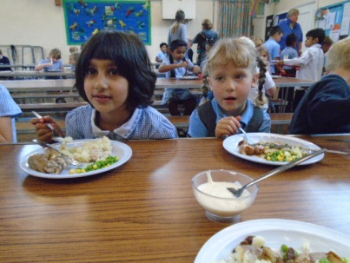
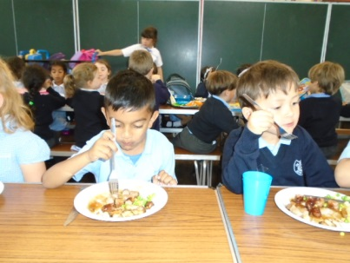

The Early Years Foundation Stage Curriculum

There are seven areas of learning and development in the Early Years Foundation Stage, all are important and inter-connected and will develop the skills the children will need in Year 1 for the National Curriculum which are explained below.

Communication and Language
The use of language is at the heart of learning. It is very important that children learn to express their needs and feelings effectively and discuss their ideas. Parents can help by providing role play opportunities and taking time to talk and really listen to their children during everyday situations without any distractions.
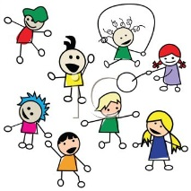
Physical Development

This is essential for health and fitness. It includes the development of gross motor control, such as balance, large scale movements and an awareness of space, and fine motor control such as manual dexterity when handling and using different tools. Upper body strength, hand-eye coordination and fine motor control are vital developmental skills to acquire before more formal skills are introduced. Providing lots of fun opportunities to play safely both inside and out with balls, tricycles, climbing frames etc.,, plus ‘fiddly’ toys and tools such as threading, Lego, beads etc., will help to develop these important skills.

Personal Social and Emotional Development

Children’s social and emotional development is really important, and underpins learning in other areas. They need to become independent, to be able to consider the needs of others, and to gain confidence in familiar group settings. Parents can develop these skills by arranging playdates, meeting up with their friends at the park etc.

Literacy

Reading and writing are taught through a phonics scheme. This is a structured scheme, with a multi-sensory approach. All children learn to read in their own time. Spending time looking at books together, enjoying rhymes and songs and reading stories regularly will help develop your child’s reading readiness. Visiting a local library or book shop to see which books are available.

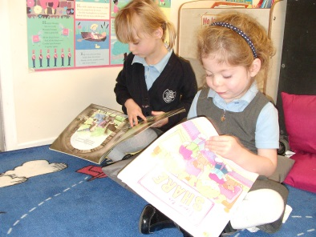
Children begin to write by mark making. This is when children write squiggles, lines, circles for example, on paper, in sand, shaving foam.
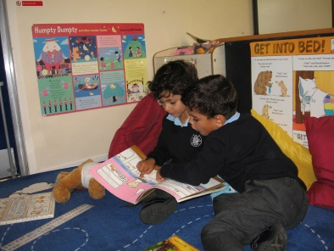

All forms of mark-making, scribbling etc., are pre-cursors to ‘writing’. Some children will find chubby chalks or crayons easier to handle than pens and pencils, or they may prefer to make marks in sand or mud with their finger, or a stick. All attempts are of equal value.

Mathematics

You can help develop the key skills of counting, sorting and matching when laying the table, shopping, sharing fairly and tidying up, sorting items by shape or colour for example. Talking about whether there is enough will lead to an awareness or ‘too many’ or ‘too few’. When building with constructions toys, use positional words such as ‘inside’ ‘on top’, between’ to support the development of early mathematical language/concepts. When playing in the bath or sink use the language of capacity e.g.,’ full’, ‘empty’, ‘overflowing’. Ordering glasses/bottles based on capacity, looking at different coins and discussing a daily routine links to time.

Understanding the World

Children learn best by first-hand experience – this helps them to make sense of the world around them. They need the chance to explore and manipulate a range of materials, such as water, wet and dry sand, dough and good old-fashioned mud! Children also benefit hugely from meeting and interacting with different people, encountering and caring for other living things, using different tools and equipment and going to places of interest.

The skills and knowledge gained from these experiences form the foundations of many subjects. Developing on early willingness to experiment, asking questions and finding out about things for themselves, gives children the ability and confidence to tackle a wide range of situations.
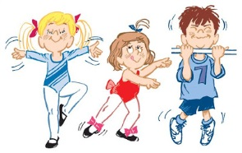

Expressive Arts and Design

This includes model making, art, music, dance, role play and imaginative play. These activities will help your child to express their ideas, feelings and preferences using all their senses. You can help by teaching nursery rhymes and tapping to the beat of familiar songs, by collecting junk and providing glue, string etc., for imaginative modelling. Role play with toys such as, Play-Mobil and Duplo, will help develop your child’s imagination.

Role Play

Part of the children’s provision is a themed role play area, which is always available for them to access. The classroom theme is changed on a regular basis and communicated to the parents so that they can support their child at home.

At the start of each role-play theme, you will receive a newsletter. There will be suggestions of activities that you can do at home to support your child’s learning in the particular theme. We also have weekly ‘show and tell’ sessions where we encourage children to bring along any object for example; a book, a picture or something they might have made at home.
We also enjoy sharing children’s recent out-of-school achievements at these sessions, for example; a swimming certificate or football trophy. We find focussed ‘show and tell’ is a very good way of developing children’s speaking and listening skills.

General Information about Oldfield Primary School Routines and Procedures

Playtimes

Early Years children have a separate morning playtime and they play in their own area at lunchtime.

Children are given their first water bottle free of charge on the first day of term and should be named. This should come into school daily refilled with fresh water – not juice. Children will be encouraged to drink their water throughout the day to ensure they stay well hydrated and their bottle will be re-filled when empty. Replacements can be purchased from the school office at £2.50 per bottle. Additional lids can be purchased for £1.50.

Snacks may be brought into school in a separate named container, for morning break time.
We want the children to eat healthily, therefore, snacks sent in from home should reflect this – fresh fruit or vegetables only. Please do not send your child in with any nuts as we do have a number of children with nut allergies. You will receive information about free or subsidised milk for your child in due course.

The school is part of a national fruit scheme which provides fruit for the children to eat at afternoon break time.

Lunchtimes

When your child starts school, you may choose whether they will have a school lunch or bring a packed lunch. From September 2014, all Infant children are offered free school meals up to and including Year 2.

The lunches are cooked on the premises and a range of three hot, healthy meals are available daily. The menus can be seen at school and on the school’s website at www.oldfieldprimary.com and have been revised to meet strict nutritional standards. Specific dietary requirements, such as allergies, can be catered for, within reason, and you should include this information on the admission form and OA4 form enclosed with this booklet. Water is freely available with hot lunches.
All children wash their hands before leaving the classroom to go to lunch.

If you choose to provide your child with a packed lunch, items included must be of a healthy nature and we would ask you not to use Chocolate/Nutella as we have a number of children in school who have nut allergies as we are nut free school . Children who bring a packed lunch to school are able to bring a non-fizzy drink. We request that this is not in a can or in a glass bottle. A named flask, bottle or carton is preferable

If you believe your child is eligible for Pupil Premium (if your family receives Income Support), please complete the relevant form within the Admission Pack.

End of the Day

The Early Years children are ready to leave at 3:20pm and we ensure each child is collected by an adult. Please wait on the KS1 playground (as per the morning) and when the children are ready to leave, a member of the EYFS team will come out to collect you to come onto the play-deck (this again will be clearly marked).
If someone other than the parent-carer is collecting the child the school needs to know who this will be. We ask you to complete a slip to be given to the teacher with these details on and copies of this slip will be included in the Admission Pack. If you are going to be delayed, please telephone the school office (01628 621750) and we will keep your child in school until you arrive – it is important that we know about any delay.
Grab and Go
Details regarding the Grab and Go system will be available in our leaflet, which will be in your Admission Pack.
Parents as Partners

At Oldfield, we strongly believe parents are children’s first and most enduring educators. When parents and teachers work together, the results have a positive impact on children’s development and learning. Every Monday, we look at the parents’ pages book. This is for you to record any significant moments in your child’s learning at home for example;
- Doing up their own buttons
- Eating a new food
- Learning a new skill
- Developing a new interest
- Using new vocabulary
You may also add anything else that surprises you! Just a brief comment to describe the moment or a photograph to capture it, will help us to know your child better and plan for their learning in school. The book will be looked at every Monday to show that your comment has been read. Parents for whom English is an additional language are very welcome to come in and tell us about any significant moments and we are, of course, always available to talk to parents about any other queries.

Home learning: After the children have settled in, we will begin to set children ‘home learning’, this will be discussed at greater detail during the parents meeting in the Autumn term.

Children can bring in a ‘small’ toy from home for playtime, car, skipping rope, doll etc., (no character or fighting toys) but please discourage children from bringing in ‘special’ toys from home as they are their responsibility.

Letters

Children will regularly receive letters from school. Please ensure any reply slips or forms that require your signature are returned to school promptly.

We use an electronic system to communicate with our parents by e-mail (with or without attached letters). You will be asked to supply e-mail addresses on the admission form. Please check the website regularly for any updates. If you do not have access to a computer on a regular basis, please inform the school office and they will provide you with a paper copy.

Lost Property

Lost property is collected and kept in a box in the EYFS classrooms. If it is named, it can be easily returned to its owner. Please remember to make sure all clothing and PE kits are clearly named. Try to encourage your child to take responsibility for their own possessions.

Occasional accidents do happen at school and we would appreciate you supplying a change of underwear and socks/tights in the children’s PE Bag.

Oldfield School Association (OSA)

We have a very active parents association who support the work of the school in many ways. They will be in touch with you as part of the induction process.

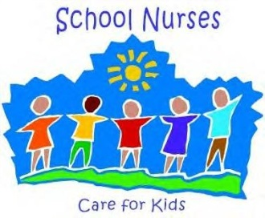
School Nurse

The school liaises with the School Nurse who makes regular visits.

The nurse will carry out a health assessment on your child during the term in which he/she is 5. This involves routine weight and height checks, along with hearing and vision tests. This enables any problems to be detected and help organised as soon as possible.

Uniform

In Early Years: Uniform for Oldfield can be purchased at Goyals or Schools Direct.

“In Early Years:

- “Tailored, dark grey trousers of the type sold by school outfitters and department stores” (not jogging pants). Dark grey shorts may also be worn if desired.
- Dark grey skirt or pinafore dress, around knee length.
- Navy blue V-necked sweater or cardigan with school crest embroidered on.
- Pale blue polo shirt.
- Hijab (Blue or Black).
- Grey leggings when worn with a summer dress.
- Grey, white or navy socks - long or short. White, navy or grey tights in winter.
- Navy, white or blue and white checked ribbons, hairbands and scrunchies.
- Traditional leather shoes in black (No trainers of any description or boots).
- Light blue checked dresses may be worn in the summer (not striped).
- PE kit for all children will be navy shorts and white polo shirts.

Once children enter Year 1, the polo shirt will be replaced by a white school shirt with collar and the school tie. Further information is available on the school website at www.oldfieldprimary.com
Other Items available but not part of the school uniform

School fleeces- available to order from the school (may be worn outside).
Hi-Viz Back Pack available from the school office. (This is not to replace to the book and PE bag detailed below) at a cost of £10.00

Children should not wear nail varnish or jewellery in school, except stud earrings or items that have to be worn for religious reasons. Please make sure your child’s class teacher is aware. Earrings should be taped over or covered for PE and Games.

On occasion, the school may have a charity event when the children are allowed into school in their own clothes, these are known as ‘Mufti’ Days. Clothes and footwear should be appropriate for being in school; no flip flops, heelies and fancy dress.

They will also need:

- NAMED PE bag (available from the school office)
- A NAMED blue book bag (available from the school office)
- NAMED Waterproof Coat (to keep in school)
- If your child is not having the universal free school meals , a packed lunch can be sent in a NAMED lunch-box (no glass bottles, sweets, or nuts please)
- One NAMED Colouring, Puzzle or Dot to Dot book for rainy days
- A NAMED drink of water only (in a school sports bottle only) New bottles are available from the school office at a cost of £2.50, and spare lids £1.50
- A NAMED healthy snack of fresh fruit or vegetables, not healthy biscuits, nuts or yoghurts for break time
- A NAMED small toy for playtime (no character/fighting toys)
General Comments

- Please name all clothes and shoes CLEARLY with name tapes or indelible markers, i.e.: Sharpie [Biro or ink washes out!], particularly those which are common like jumpers.
- Please keep to clothes on the uniform list and try to choose clothes easy for your child to manage when they change for PE .
- Never send loose money in, but use a purse belt or a named envelope and state what the money is for - the children often can’t remember! If you are sending in money for a trip/activity, please hand to a member of staff in the classroom.
- Please dress your child according to the weather. If it is cold, please send in hats, gloves and scarves clearly named. In the warmer weather we would ask you to provide a sun hat. Please apply sun cream before school as necessary.
- If your child is on medication such as an antibiotic, they should be at home getting plenty of rest. If it is really necessary for us to administer medicine during the day, please call into the office to fill in a form. We also need clear instructions on how and when the dose is to be taken. If your child is on medication for asthma, please ensure you complete the form enclosed with the admission form pack.
- If your child is not well enough to attend school, then please contact the office by telephone in the first instance, preferably before 9.30am. On return the child should bring with them a letter signed by the parent or carer outlining the reasons for their absence. If your child needs to attend an appointment i.e. dentist or doctors, a letter still needs to be sent into school.
- If your child has suffered from vomiting or diarrhoea, they are unable to attend school for 48 hours.
- Obviously it is important for your child to be in school as much as possible. Term time absences are only authorised in exceptional circumstances and not for holidays. An official ‘Request for Exceptional Leave of absence’ form must be completed 14 days before the start date.
- When entering or leaving the school on foot, during the school day, please ALWAYS use the main school entrance.
- If your child will be arriving late or if it is necessary to collect them early (i.e; Doctor’s appointment), please let the class teacher know in advance in writing. Children must be collected from the office in order that they can be signed out safely.
- If your child requires a school lunch and will be late into school, an order for this must be made by 10.00am of the morning the lunch is required as meals are cooked to order. You can always pre-order with the class teacher the day before.
- At the end of the school day you may wait in the playground to greet your child. The school gate will be unlocked at 3.00pm.
- Please inform the teacher if a different person from usual is collecting your child (slips to complete can be found in the pigeon holes in the school main reception area). If it is a permanent childminder/person who always collects them, an introduction to the teacher is most helpful together with a signed letter informing the school of this arrangement.
- Please would all children bring a box of tissues at the start of the year – we get through hundreds!
- Class Fund – a voluntary contribution of £3.00 each term (no cheques please). This helps to pay for all the “extras” such as extra making resources, ingredients for cooking activities and role-play resources
- Check your child’s hair regularly for nits.
- If you have any enquiries, please talk to the member of the team outside in the morning; any longer conversations with the teacher may require an appointment before or after school.

We would appreciate your co-operation in these matters to ensure that the maximum amount of time can be spent on education.

Extra-Curricular Activities

As a school, we do run a large number of after school activities, both by school staff and outside approved agencies. We do not normally offer any clubs for the Early Years children until at least the Summer term as the school day is already long and tiring for them.

Children at Oldfield swim 3 times during curricular time, firstly in Year 1, Year 3 and again in Year 5.

School Calendar of Events

At the beginning of the academic year, we will publish a list of activities planned for the year. Parents are invited to some activities i.e.; Sports Day, Performance Day and some Parent Assemblies. Please look at out for further information/letters when these dates approach.

Early Riser’s Club

We run a breakfast club for children of working parents from 8.00am in the morning with costs from £2.50 per day. Further information about this can be found on our website at www.oldfieldprimary.com

